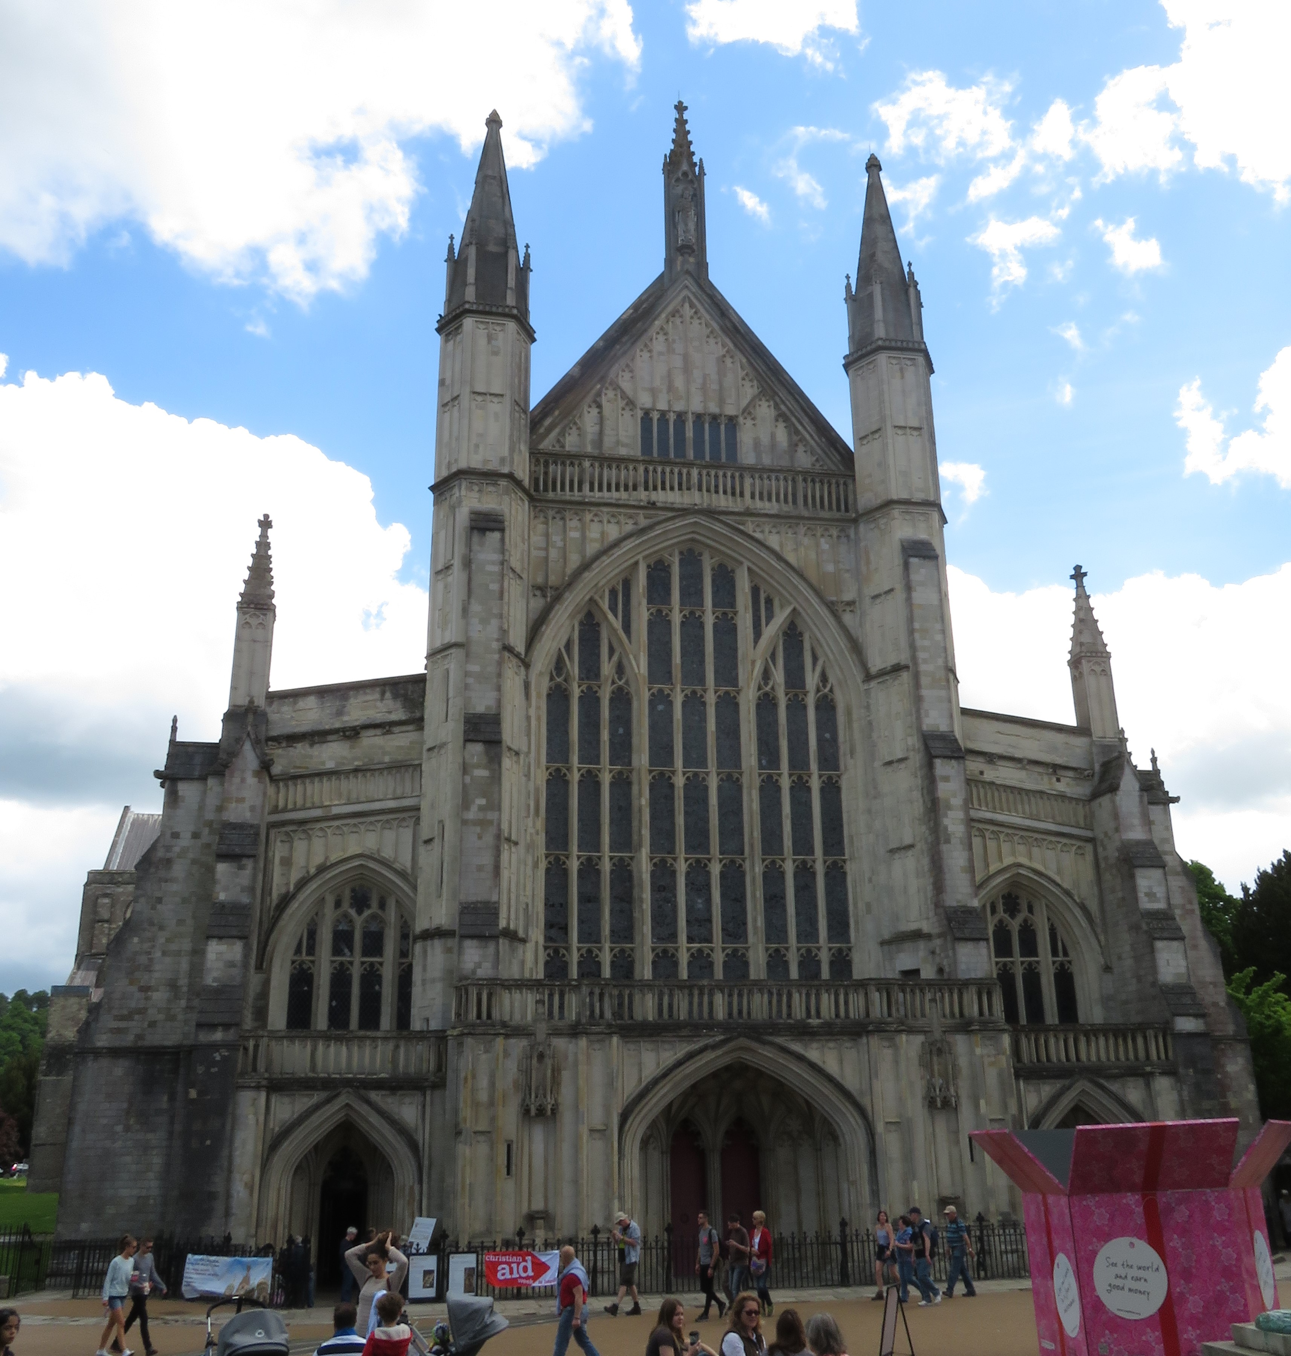  Ely Cathedral – Norman Architecture  Style of Norman Architecture  Norman architecture dates back to the time of the Norman Invasion in 1066. These three cathedrals, Peterborough, Ely, and Winchester, were all built between 1079 and 1118. Each cathedral has some definite characteristics to it, which include:  - Tall support columns through nave  - Pointed arches and windows  - Stained glass windows  - Pointed high towers  - Spiral staircases  - Ceiling designs | Picture Gallery of Norman and Victorian Architecture | Norman and Victorian Era  - Comparing the Architecture and Lifestyle of the Two Eras.  - By Dakota Payette
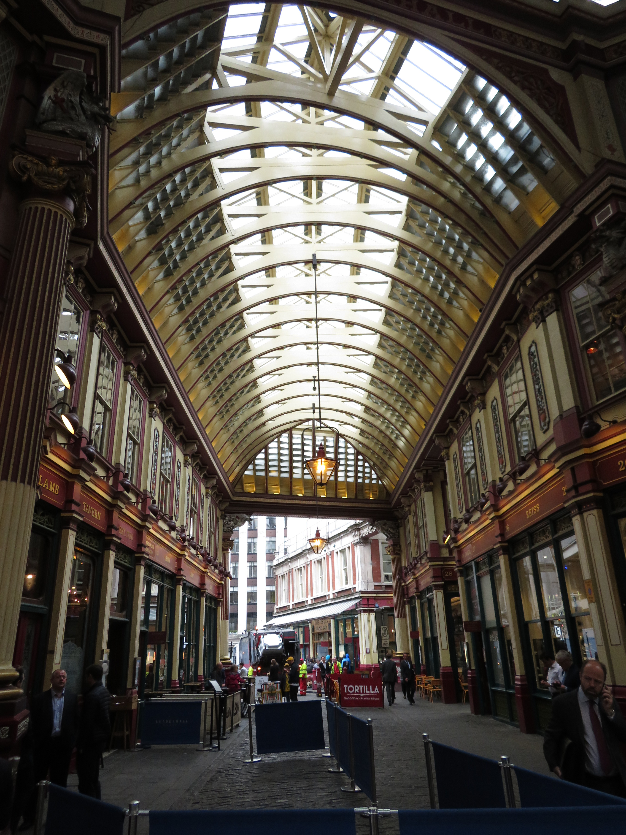  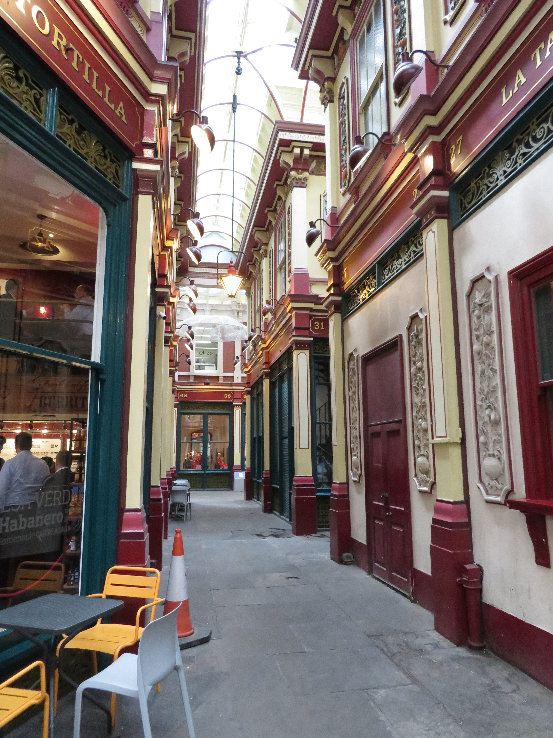  Leadenhall Market – Victorian Architecture  Style of Victorian Architecture  Victorian architecture was very different from Norman. Shops were close together and streets were very narrow. The pictures above and in the gallery show just how actual streets were like. Sir Horace Jones reconstructed Leadenhall Market in 1881 so it could include these Victorian architectural features.  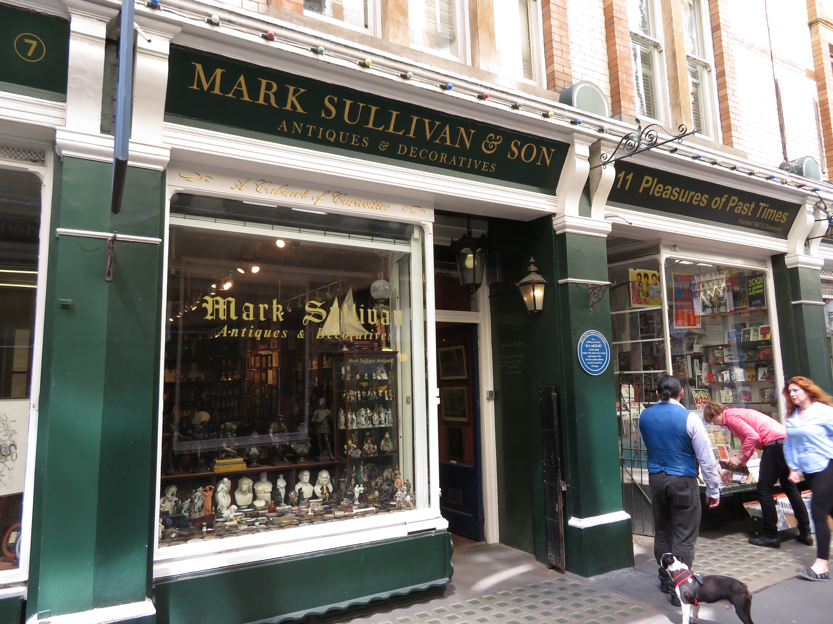 | Norman Lifestyle  The Norman Era took place during the High Middle Ages. This was still a feudal society, so the social classes were broken down into Kings and the Clergy, Barons and Lords, Knights, and Merchants and Serfs.  King and Clergy  The King was the highest position in medieval England, and alongside members of the Clergy, their combined power was unstoppable in most cases.  Barons and Lords  Barons and Lords controlled individual portions of land, and then reported to the King. If enough got together, they could pose a revolutionary threat to the King.  Knights of England  The Knights of England were called upon to protect their land when enemies attacked. They were very respected all throughout the land.  Merchants and Serfs  Part of the lowest class, members were disrespected and had to do some of the worst work imaginable. They had no way to escape their miserable lives. | Victorian Lifestyle  The Victorian Era, 1837-1901, had more rigid social structures and had underlying social norms about what each class could and couldn’t do. It was broken down into The Aristocrats, The Middle Class, and the Lower Class.  The Aristocrats  The Queen, Her Lords and Ladies, and the Great Offices of State filled this class. They were the highest and most important ranking officers in the Empire. Everyone looked up to them.  The Middle Class  Broken up into Upper and Lower sections, The Middle Class was the average everyday adult who went to a good paying job. The type of job one held determined their place in the class. It was ideal for most to spend their entire life in this class.  The Lower Class  Consisting of The Working Class and The Poor, this was the class that no one wanted to be a part of. The Working Class spent far too many hours working and got paid so little for their hard labor. The Poor were usually homeless and held no stable income to sustain themselves.

